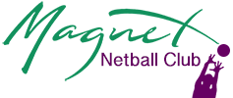
OPT IN Statement
I have been made aware of the risks associated with netball activity and COVID- 19 and understand this. I also understand there are some people who are of high risk of contracting COVID- 19.
I am comfortable with the information I have been provided with and opt in to participate in netball.
I also confirm I understand the requirements and steps I need to take to help prevent the spread of COVID- 19 through netball and agree to take all these steps.

Full Name

Team

Date

