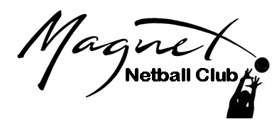
MAGNET NETBALL CLUB
Known as ‘MAGNETS’
Senior Players (Over 18’s)
Code of Conduct

The Magnet Netball Club wishes netball to be an enjoyable and positive experience for all netball players.
Please use these guidelines to support your club and fellow players in a manner that will enable you and others around you to enjoy your netball.

Please:
- Accept responsibility in ensuring you are up to date with the laws of netball, understand and adhere to them.
- Encourage your team members to learn the rules of netball and play within them.
- Recognise the valuable contribution made by coaches and officials who are usually volunteers. They give their time and resources to provide netball for you.
- Publicly accept officials' judgements.
- Discourage unfair play and arguing with officials by anyone, both on and off court.
- Be a positive role model; treat other players and officials with the same level of respect you would expect to be shown to you.
- Recognise fair play and applaud the good performances of all, including the opposition.
- Accept success and failure, victory and defeat equally.
- Use correct and proper language at all times.
- Encourage everyone to enjoy the sport of netball and understand that people have different motivations to playing the game.

Respect the rights, dignity and worth of all participants regardless of their age, gender, ability, cultural background, religion or sexual orientation.

Sign here: …………………………………………………………………….. Date: …………………………….

NOTE: IN ORDER TO REDUCE VAST AMOUNTS OF PAPER USAGE PLEASE MAKE SURE THAT YOU SIGN THE RELEVANT SECTION ON THE REGISTRATION FORM STATING THAT YOU HAVE READ AND AGREE WITH THIS CODE OF CONDUCT.

