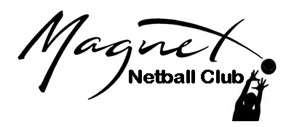
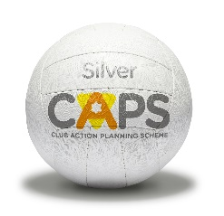
MAGNET NETBALL CLUB
Known as ‘MAGNETS’
Junior Players (U18’s)
Code of Conduct

As a player in an England Netball Club I agree to the following:

- I will play within the rules and respect officials decisions
- I will be respectful to England Netball coaches, team managers, officials and volunteers, for the time they give to my sport.
- I will respect and never underestimate my opponents, and not try to gain an unfair advantage over them.
- I will encourage and support my fellow team members at all times without behaving in an unsporting way towards our opponents.
- I will always do my best in every situation.
- I will accept success and take victory and defeat equally. Win or lose I will try to enjoy every moment on court.
- I will not use foul or other inappropriate language.
- I will not smoke or consume alcohol or drugs of any kind whilst representing the club or participating in club activity.
- I will be punctual at all times for training and competition and be ready and prepared at the appropriate times.
- I will pay any fees for training and matches promptly.
- I will always inform my coach or the team manager of any injury or medical condition which may affect my performance.
- I will take responsibility for myself in and out of competition or training; including ensuring I have the appropriate and required kit for netball.
-----------------------------------------------------------------------------------
I accept the Code of Conduct as above and will respect all fellow netballers regardless of age, gender, ability race, cultural background, religious beliefs or sexual identity.

Sign here: ………………………………………………………………………………….. Date: ………………………

NOTE: IN ORDER TO REDUCE VAST AMOUNTS OF PAPER USAGE PLEASE MAKE SURE THAT YOU SIGN THE RELEVANT SECTION ON THE REGISTRATION FORM STATING THAT YOU HAVE READ AND AGREE WITH THIS CODE OF CONDUCT.

